Student Polling

ERD

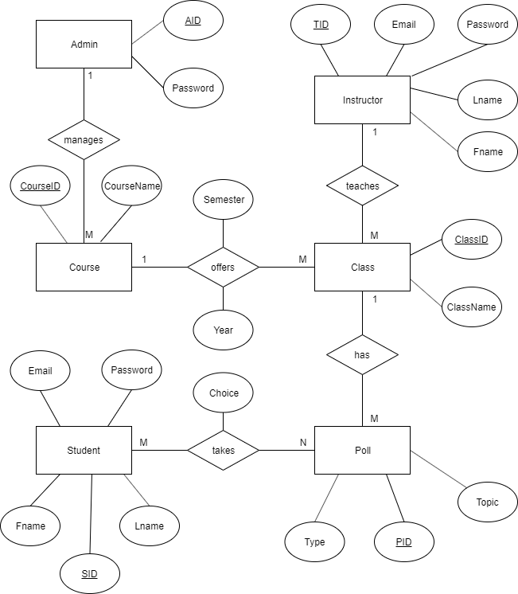

The ERD shows the information of each of the tables in the database. Each of the rectangles are the tables and the bubbles that connect to them are columns that hold the information in the table with the underlined bubbles being the Primary Key. Since the tables need to connect with each other the diamonds are the linking tables so they can connect the information between them while also showing how they correlate for each other. So for instance the Instructor table connects to the Class table through Instructor_teaches_Class. These connect 1 to many since 1 instructor can teach many classes but each class is only taught by one instructor.

System Architecture

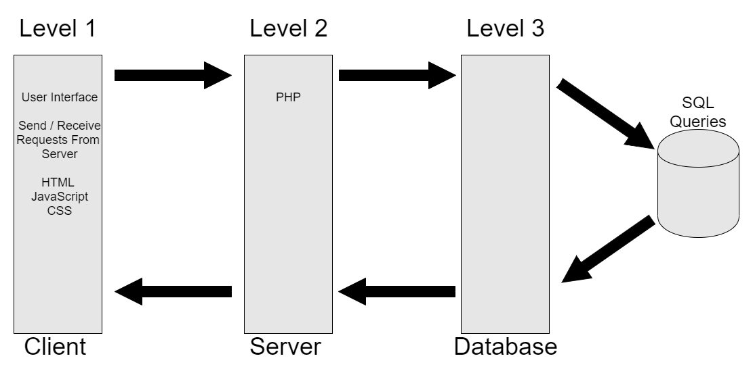

The system architecture shows how my three-layer architecture is being used. The first level is the client level. This level is what the user sees and does, it has the information that the browser needs in order to display the site to the user and sends and receives requests from the user to the server. The second level is the server that it is stored on, this is where the PHP code is handled. Lastly, level 3 is the database where all of the information is stored, the database can send SQL queries to get information and send it back to where it is needed. All of these levels can send and receive information with each other and are needed in order for the web application to be functional.

Usage Diagram

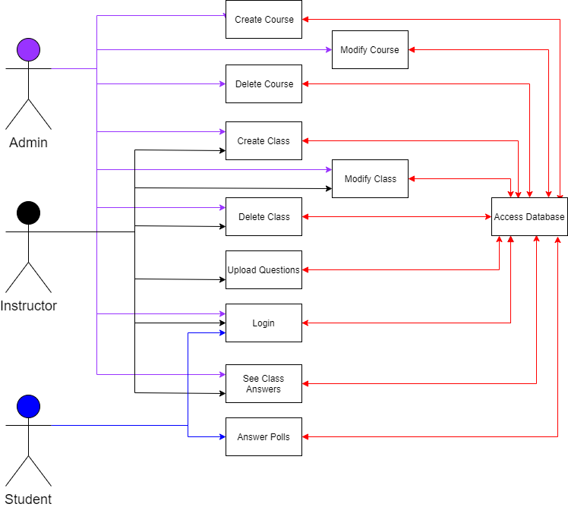

The usage diagram shows what each account type can do in a more simplified manner. Each account is colored coded so it is easier to read and its arrow points directly to what they can specifically do. For instance, while an admin create courses and classes, they are not able to upload questions or answer polls. The diagram also shows how every action the user does can send and receive information from the database, but they are never specifically accessing the database.